Notice

Notice No-178 Date-22.09.2023

This is hereby notified that the Hostel admission for Girls both P.G & U.G for the Session2023-24 will be started from 1st October 2023 to 15th October 2023.
The desired students are requested to come to the college office for the admission into the “GIRLS HOSTEL” from 10 A.M to 5P.M
They are advised to pay the following fees towards their admission
Detail of Hostel Fees for 2 Years
1 | Admission Fees(1st Year) | Rs 5000/-
2. | Boarding & Messing  & Other Fees inclusion of Breakfast Lunch & Dinner (1st Year) | Rs 40000/-
3. | Readmission Fees (2nd Year) | Rs 2000/-
4. | Boarding & Messing  & Other establishment, electricity and maintenance fees including of Breakfast Lunch & Dinner (2nd Year) | Rs 40000/-

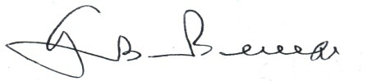
Principal
Govindpur (Degree) College

Copy forwarded to
- General Notice Board
- Staff Common Room
- Boy’s Common Room
- Girl’s Common Room
- Devi Girls Hostel

